**COSC 2325 Computer Organization Assignment 5**

**Due: 23:59pm, 10/03/2022**

**Andrew Kalathra**

**L20498001**

1. (1) Compute bitwise operation*:* 0x2325 or 0x1234 (15 points)

0000 0000 0000 0000 0011 0011 0011 0101

→ 0x3335

* 1. Compute bitwise operation*:* 0x2325 and 0x1234 (15 points)

0000 0000 0000 0000 0000 0010 0010 0100

→ 0x224

* 1. Compute bitwise operation*:* 0x2325 xor 0x1234 (20 points)

0000 0000 0000 0000 0011 0001 0001 0001

→ 0x3111

1. Please write an assembly program to do the following operations.

* + 1. Put the bit pattern 0x2325 into register $6.
    2. Use *ori* instruction to apply *logic or operation* to 0x1234 and register $6, and save the output in register $7
    3. Use *andi* instruction to apply *logic and operation* to 0x1234 and register $6, and save the output in register $8
    4. Use *xori* instruction to apply *logic xor operation* to 0x1234 and register $6, and save the output in register $9

**You need to submit a *\*.asm file* and a *screenshot* of the simulator output for this question**. **Please do NOT zip your submission**. (50 points):

If you use a QtSpim simulator, the screenshot should look like below (Chapter 9 video, 25:08) to show the register values.

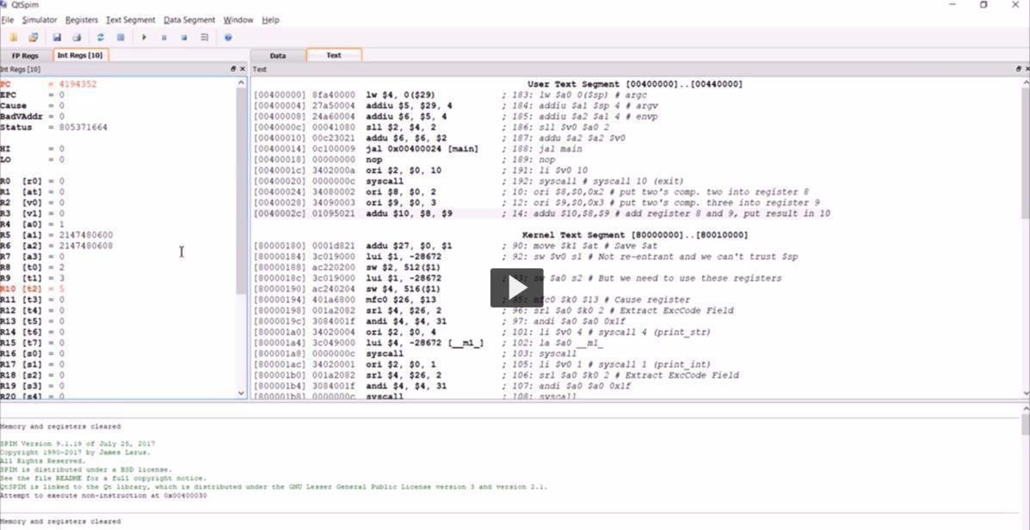If you use a Mars simulator, the screenshot should look like below (Chapter 9 video, 29:10) to show the register values.

